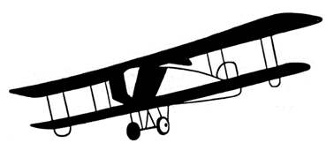

**Boyceville Aviation Scholarship**

The Boyceville Airport Booster Club is offering aviation related scholarships. The purpose of these scholarships is to share the joy and fun of flying, and to enhance the world of aviation by encouraging aviation education.

To apply for a scholarship, the following criteria must be met.

1. Scholarship funds are to be used for the pursuit of further education. This will include but is not limited to: pilot training, obtaining an advanced license or type certificate, mechanics training, air traffic control training, and/or attending an accredited aviation training program.

2. Applicants from Northwestern WI that are actively involved in the local aviation community are given preference.

3. Anyone age 15 or older. Yes, adults may apply. This scholarship is not limited to high school or college students.

4. The amount of the scholarship will be determined by the scholarship selection committee, which will consist of members of the Boyceville Airport Booster Club.

5. Scholarship funds will be paid after: a) the student’s first solo flight, b) after successfully completing one semester of an accredited education and signed up for another term. c) other criteria as set forth by the selection committee.

----------------------------------------------------------------------------------------------------------------------------------------

***Application Process:***

1. Your application will include:

Name Address Phone number(s) Age Email address

2. Your application will include answers to the following 4 questions.

· Tell us a little about yourself.

· How did you become interested in aviation?

· What has been your involvement in aviation?

· What are your short- and long-term goals?

· What additional information would you like to share with us?

3. Your application will be limited to one typed page.

4. Send all applications to: Boyceville Airport Booster Club 803 Airport Dr.. Boyceville, WI 54725 or our Email address: boycevilleairportclub@gmail.com

5. Applications are accepted all year. However, the scholarship committee meets to review applicants in the spring and the fall.